CAN SCIENCE HELP SAVE THE PARISH?
Presenting a fresh explanation of church.
Ken Miles April 2023
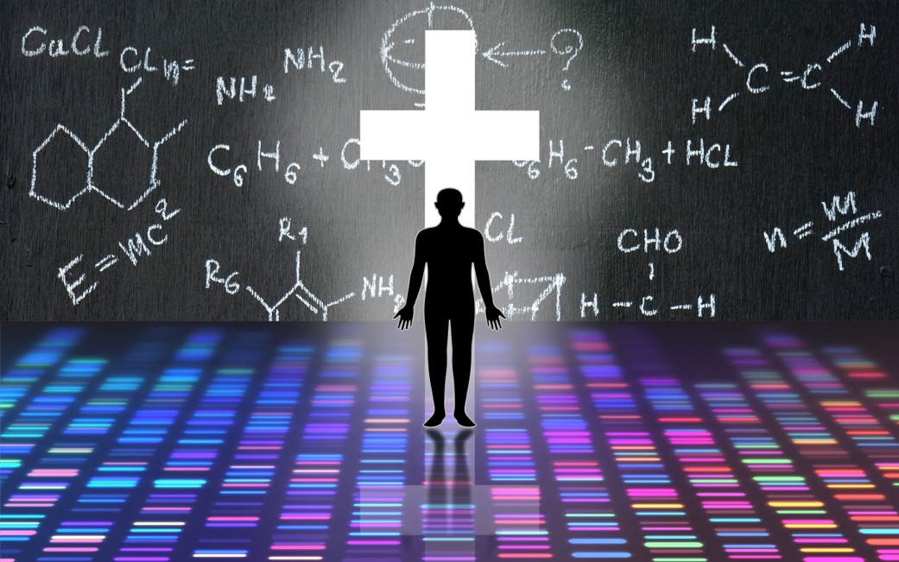

Are church buildings and ordained ministry valuable assets or (as has been suggested) “limiting factors” in the life of the church? This question is central to the current debate within the Church of England concerning the merits of parish-based worship as opposed to alternative approaches which do not require a relationship with a church building nor ordained leadership. To date, the debate has largely been conducted on biblical or theological grounds. But there is another voice which can contribute to this dialogue – science, not pure science but science blended with Christian thinking. Scientific knowledge can be looked at afresh while allowing for the existence of God.

At first glance, the objectivity of science might seem to be at odds with the sorts of experience that we normally associate with a life of faith. But the Christian virtues of humility, patience, penitence, and love can be applied to science in a manner analogous to the approach biblical historian NT Wright has proposed for historical research. At the interface of science and religion, the foremost of these virtues are humility and penitence: humility to accept that a complete understanding of the natural world is unlikely ever to be achievable, and that a deeper understanding can be reached by engaging with other disciplines; penitence in the acknowledgement that current scientific assumptions and theories may have distorted our view of reality and that we have preferred the distortions. There are two assumptions that warrant special consideration. First, science’s assumption that there is nothing beyond nature should be recognised as a methodological simplification rather than truth. Second, we should accept that constraining theories to those based only on data which can be independently verified may mean that unique insights about the cosmos and human life are overlooked.

If we reinterpret scientific studies of worship while allowing for the existence of God, we discover that specific ways in which words are spoken, and the bodily postures and actions undertaken during worship are not arbitrary customs adopted only for their symbolic meaning. They bring about a range of beneficial outcomes which can be supported by scientific data (see textbox below). Moreover, ordained leadership, inherited church architecture and the visible presence of worship within a community are identified as factors that can enhance these benefits.

Thoughts and Beliefs
- Linking religious ideas to specific gestures and body positions can make abstract concepts easier to understand and remember.
- Saying words in specific ways and participating in worship actions can support belief in God.
- Narratives that are performed as well as spoken during worship can greatly influence attitudes and behaviours.
Health
- Physical activities that form part of worship contribute to better physical health.
- Postures and movements can affect thoughts and emotions in ways that boost mental health.
Signalling belief to others
- Worship actions can lead others to a life of faith by signalling a genuine commitment to God.
Openness to God
- Worship services can bring about conditions that facilitate God’s cooperative action with individuals and communities of faith.
Textbox: Summary of the effects of worship indicated by scientific studies interpreted in a Christian context.

Buildings are Important.
Church buildings are not simply locations for worship. The design, shape, and features of religious settings can impact significantly on worship experiences. For example, one study has found that worship spaces which are visually complex and open to exploration are associated with greater satisfaction, feelings of restoration, and more positive emotions among congregants. Science has also enabled us to see how some features of inherited church buildings make best use of the mental and physiological processes that become activated during worship.

Neuroscience has shown that thinking about concepts for God is fundamentally interlinked with brain activity related to the processing of spatial information. The upright columns and arches commonly found within traditional church buildings can therefore help worshippers to reflect on the divine by connecting their mental images for God to everyday body-based experiences. The value of addressing the congregation from a pulpit is highlighted by data showing that people respond more quickly to and are more likely to recall God-related concepts when they are presented higher in visual space. Moreover, when people encounter God-related words, their visual attention is systematically shifted upwards, drawing their attention to features located high in space (such as stars on the ceiling). This shift in attention can bring about physiological changes that not only promote physical and mental well-being but also influence emotions, thoughts, and decision-making. These advantages may be lost all to easily if secular buildings without such features are used for worship.

Science can even identify benefits from simply having within a community a building that is clearly intended for public worship. A growing body of evidence suggests that people are more likely to believe in God if they witness behaviours that signal to others a genuine belief. Scientific studies have found that a lack of exposure to religious actions contributes to religious disbelief while the onset of atheism is shorter for individuals who witness fewer displays of this kind. The system of parish churches ensures that actions which signal a commitment to God can be seen in every community. A group of cars and pedestrians collecting in response to the sound of church bells is highly observable and a building that is unmistakably dedicated to worship provides a clearer signal than a secular building co-opted for religious activities. On the other hand, expressions of church which involve getting into a car to attend worship in a multi-purpose building in a different town or village are at risk of reducing community exposure to religious actions and in so doing, worsen unbelief.

Online environments pose additional challenges because worship is distributed across several different buildings, including the participants’ own homes. At best, attendance at online worship will be visible only to those who have joined the activity (provided conferencing software has been used) and therefore unnoticed by the community at large. Changes in posture and other bodily actions tend not to be a part of online worship, reducing the beneficial effects of worship on physical and mental well-being, beliefs, and behaviours.

The Benefits of Ordained Worship Leaders
There is evidence to indicate that favourable changes in bodily and mental processes are more likely to occur when worship is led by an ordained priest. The physiological changes triggered by a shift of attention (as described above) have been shown to be more intense and prolonged when the stimulus is a person one would follow carefully to learn something. A separate brain imaging study also found that when an individual hears someone praying for them, their assumptions about the speaker’s abilities shapes the way their mental processes are affected. The effects are largest and associated with a greater sense of God’s presence when the speaker is considered to have influential authority. These results resonate with the finding that Christians value receiving prayers from a priest more than prayers from other Christians. While it is possible for lay worship leaders to inspire such reactions, the fact that ordained ministers have received lengthy training and are perceived to be uniquely and intrinsically transformed to represent Christ carries significant weight for many worshippers.

An ordained minister is also required for the Eucharist, and ritual actions such as those typically performed during the Eucharist have distinct advantages which are confirmed by scientific research. One study comparing the survival of religious and secular communities over several decades, found that religious communities tended to last longer, especially those communities which emphasised ritual. Ways of being church that reduce the role for ritual and/or adopt a more secular approach may therefore be less likely to last in the longer term. This conclusion is supported by other areas of scientific research. One body of evidence suggests that, by making the brain process actions with an unclear purpose, rituals cause the participants to become more open to the accompanying narrative. Moreover, the links between mind and body revealed by science provide a basis for the concept that worship narratives embodied with actions are more likely to be associated with changes in behaviour that subsequently make a difference in the world.

Within Anglican worship, there are certain forms of words which can only be spoken by an ordained minister, for example the ‘you’ form of the Absolution (e.g., “Almighty God …., have mercy upon you, pardon and deliver you from all your sins” etc). Those who are not ordained should use ‘us’ instead of ‘you’. Church of England guidance states that “The printing of any of these absolutions in either the ‘you’ or ‘us’ form has no doctrinal or other significance”. However, this advice is not borne out by health communications research which shows that changing the point of view, for example from the second person ‘you’ to the first person ‘us’, can have a significant impact on how people respond to language. The use of ‘you’ fosters the development of memories and enhances emotional response. With the ‘you’ form of the Absolution, the congregation are therefore more likely to feel that they are experiencing the event, reinforcing the greater sense of God’s presence felt when receiving prayer from a person of influential authority (as outlined above).

Fresh Explanations and Fresh Expressions
Although the implications of the scientific research summarised in this article are not definitive, there is enough data to suggest that some church leaders may have underestimated the value of church buildings and ordained ministry. The scientific principles underlying evidence-based medicine state that, when there is less than perfect evidence, decisions should be made using the best evidence available. On that basis, priests in the pulpit (both literally and figuratively) should be regarded as important for the future of the church. Notably, no equivalent evidence has been offered to support alternative ways of being church. But why should the church take notice of science?

The natural world which science explores is important to Christians. The bible describes how the natural world takes part in worship (e.g. Psalm 148, Revelation 4) and items from the natural world play a central role in some forms of worship: water in Baptism, bread and wine in the Eucharist. And just as Jesus used publicly available knowledge about the natural world in many of his parables, we can use publicly available science to enrich our understanding of worship and to communicate that understanding in a clear and culturally relevant way.

Religious actions can appear obscure to those outside the church. Yet, by showing how these actions promote well-being, support the absorption of religious knowledge, and strengthen the belief of worshippers, a blend of science and Christian thinking can deliver a fresh explanation of church which engages with contemporary society in a new way. Simplifying worship to improve accessibility could prove counter-productive unless, as missiologist Stefan Paas argues, new approaches to mission “guard the core Eucharistic event and build paths towards this core”. The enhanced understanding of worship offered by a combined theological/scientific approach can help to keep the Eucharist at the centre of church life, while informing strategies for mission which offer compelling and accessible pathways to this core.

We are currently being asked to reshape our church into something “simpler, humbler and bolder”. Perhaps a humbler church might acknowledge that it may have failed to consider all relevant knowledge before developing a strategy for the future. And if we are bold enough to factor in the available scientific data (reinterpreted within a Christian framework) we might discover that simpler ways to live and share the gospel may not be the most effective for transforming lives. Perhaps explanation is needed more than simplification.

Ken Miles is an academic radiologist and author of “From Billiard Balls to Bishops: A scientist’s introduction to Christian worship”, published by Wipf and Stock.

Meagher, Benjamin R. “Deciphering the Religious Orientation of a Sacred Space: Disparate Impressions of Worship Settings by Congregants and External Observers.” Journal of Environmental Psychology 55 (2018) 70–80.
Meier, Brian P., et al. “What’s ‘Up’ with God? Vertical Space as a Representation of the Divine.” Journal of Personality and Social Psychology 93 (2007) 699–710.
Meier, Brian P., et al. “God Is Up? Replication and Extension Attempts of Meier et al. (2007).” Psychology of Religion and Spirituality (2021).
Chasteen, Alison L., et al. “Thinking of God Moves Attention.” Neuropsychologia 48 (2010) 627–30.
Langston, Joseph, David Speed, and Thomas J. Coleman III. "Predicting age of atheism: credibility enhancing displays and religious importance, choice, and conflict in family of upbringing." Religion, Brain & Behavior 10.1 (2020): 49-67.
Kondoh, S., et al. “Experiencing Respect Elongates the Orienting Response.” 2020.
Schjoedt, Uffe, et al. “The Power of Charisma—Perceived Charisma Inhibits the Frontal Executive Network of Believers in Intercessory Prayer.” Social Cognitive and Affective Neuroscience 6 (2011) 119–27.
Thunström, L., & Noy, S. (2019). The value of thoughts and prayers. Proceedings of the National Academy of Sciences, 116(40), 19797-19798.
Sosis, Richard, and Eric R. Bressler. “Cooperation and Commune Longevity: A Test of the Costly Signaling Theory of Religion.” Cross-Cultural Research 37 (2003) 211–39.
Schjoedt, Uffe, et al. “Cognitive Resource Depletion in Religious Interactions.” Religion, Brain & Behavior 3 (2013) 39–55.
Wei, Lewen. “Exploring the Effects of Interactive Narratives in Promoting Health Behaviors.” MA thesis, 2017.

